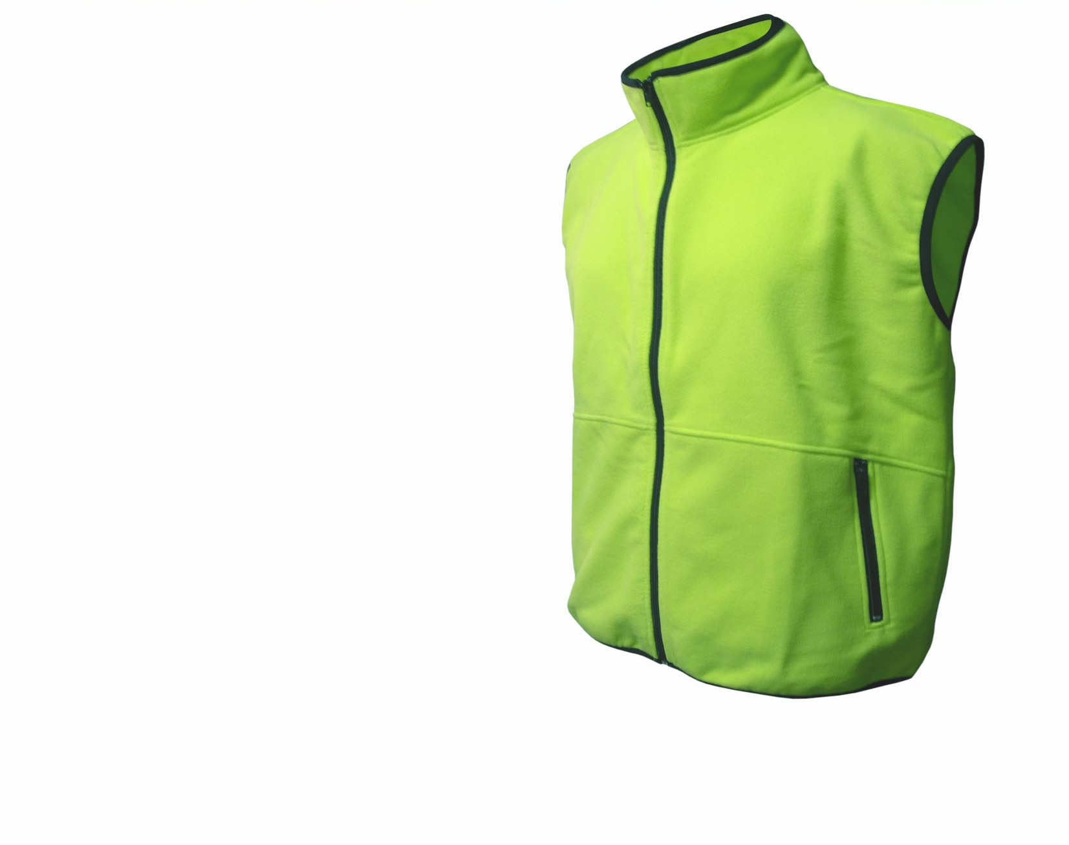
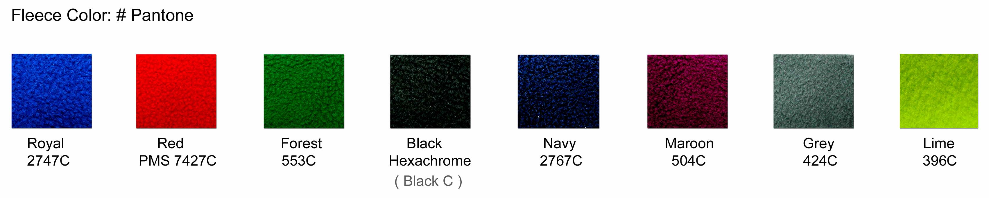

Style: Gilet with contrast piping
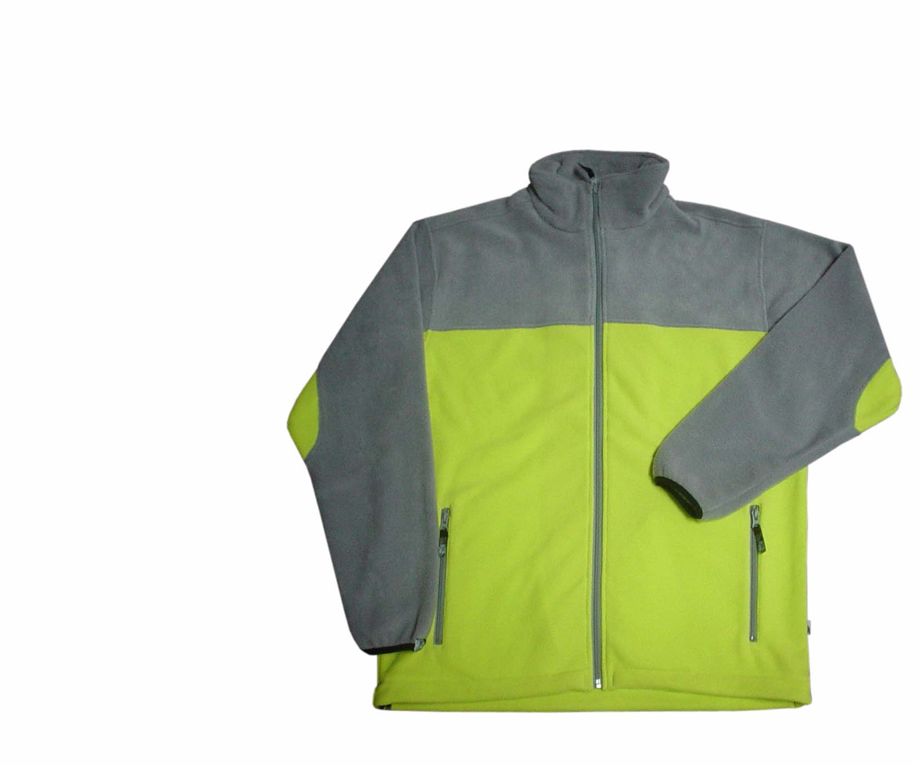

Style: 2 color Jacket
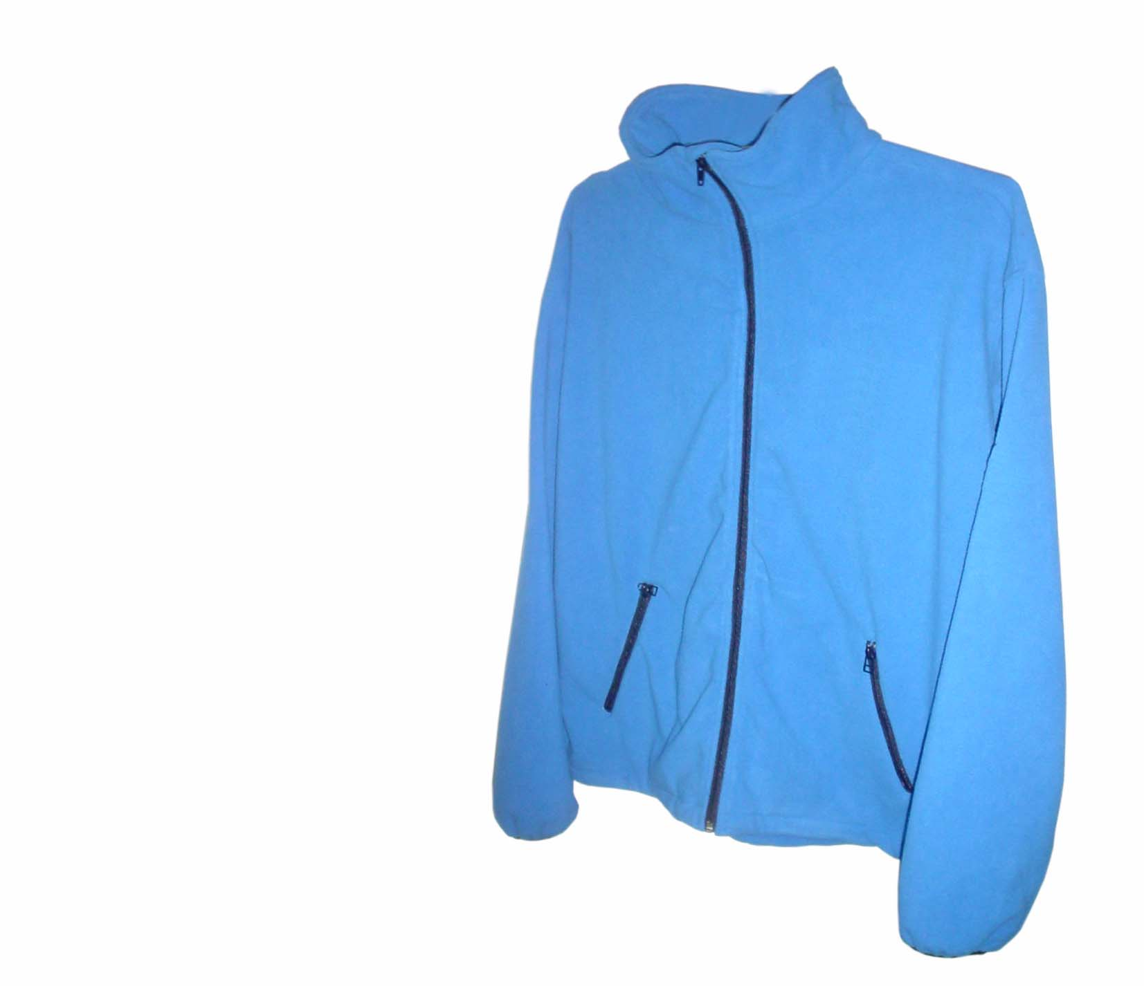

Style: 1 color Jacket
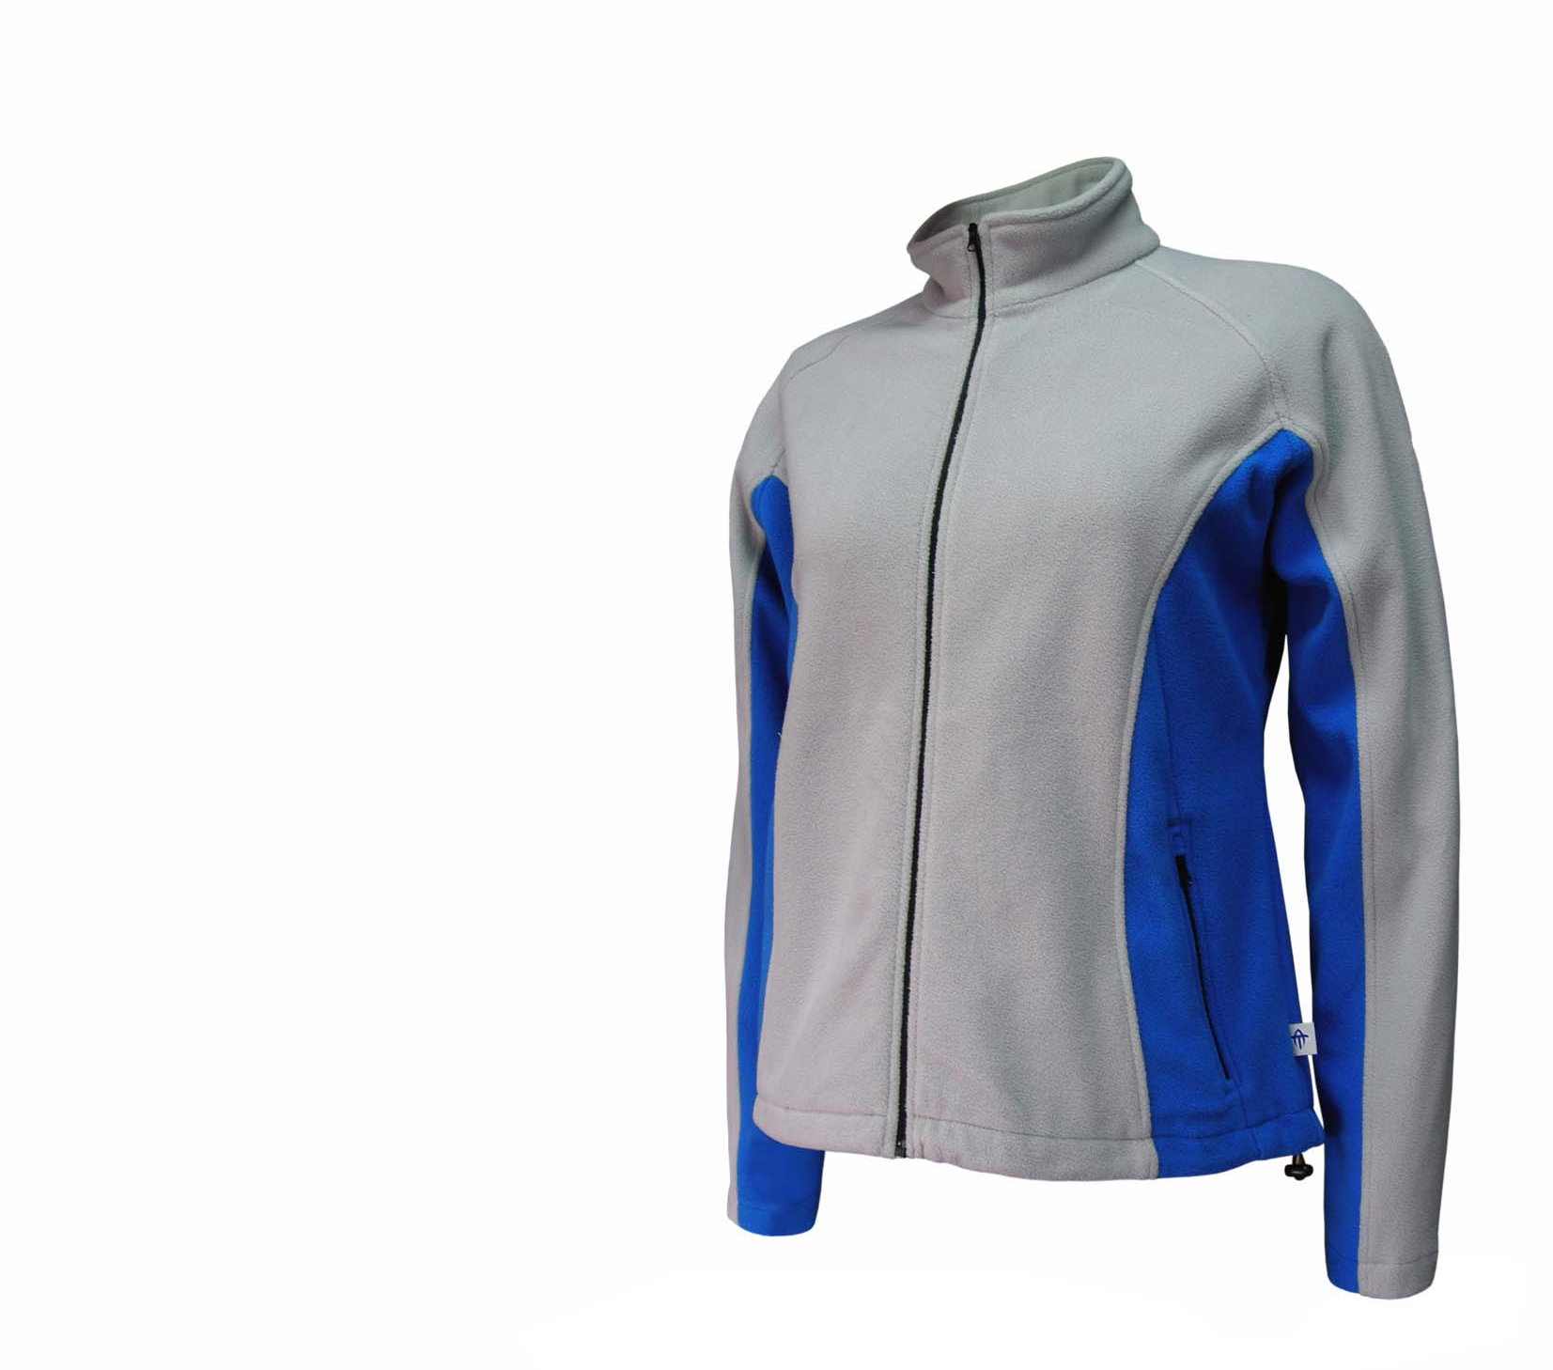

Style: Ladies Jacket contrast under arm
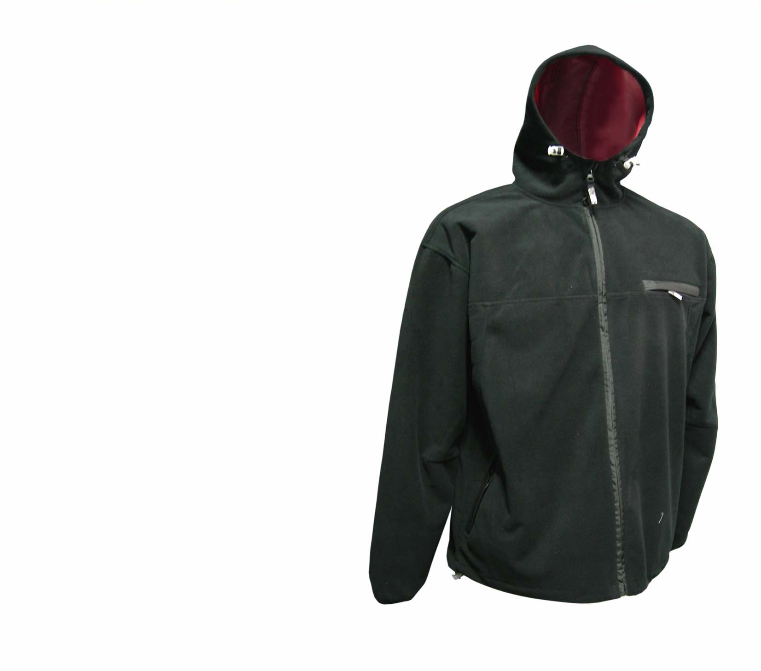

Style: Waterproof Fleece Jacket Men
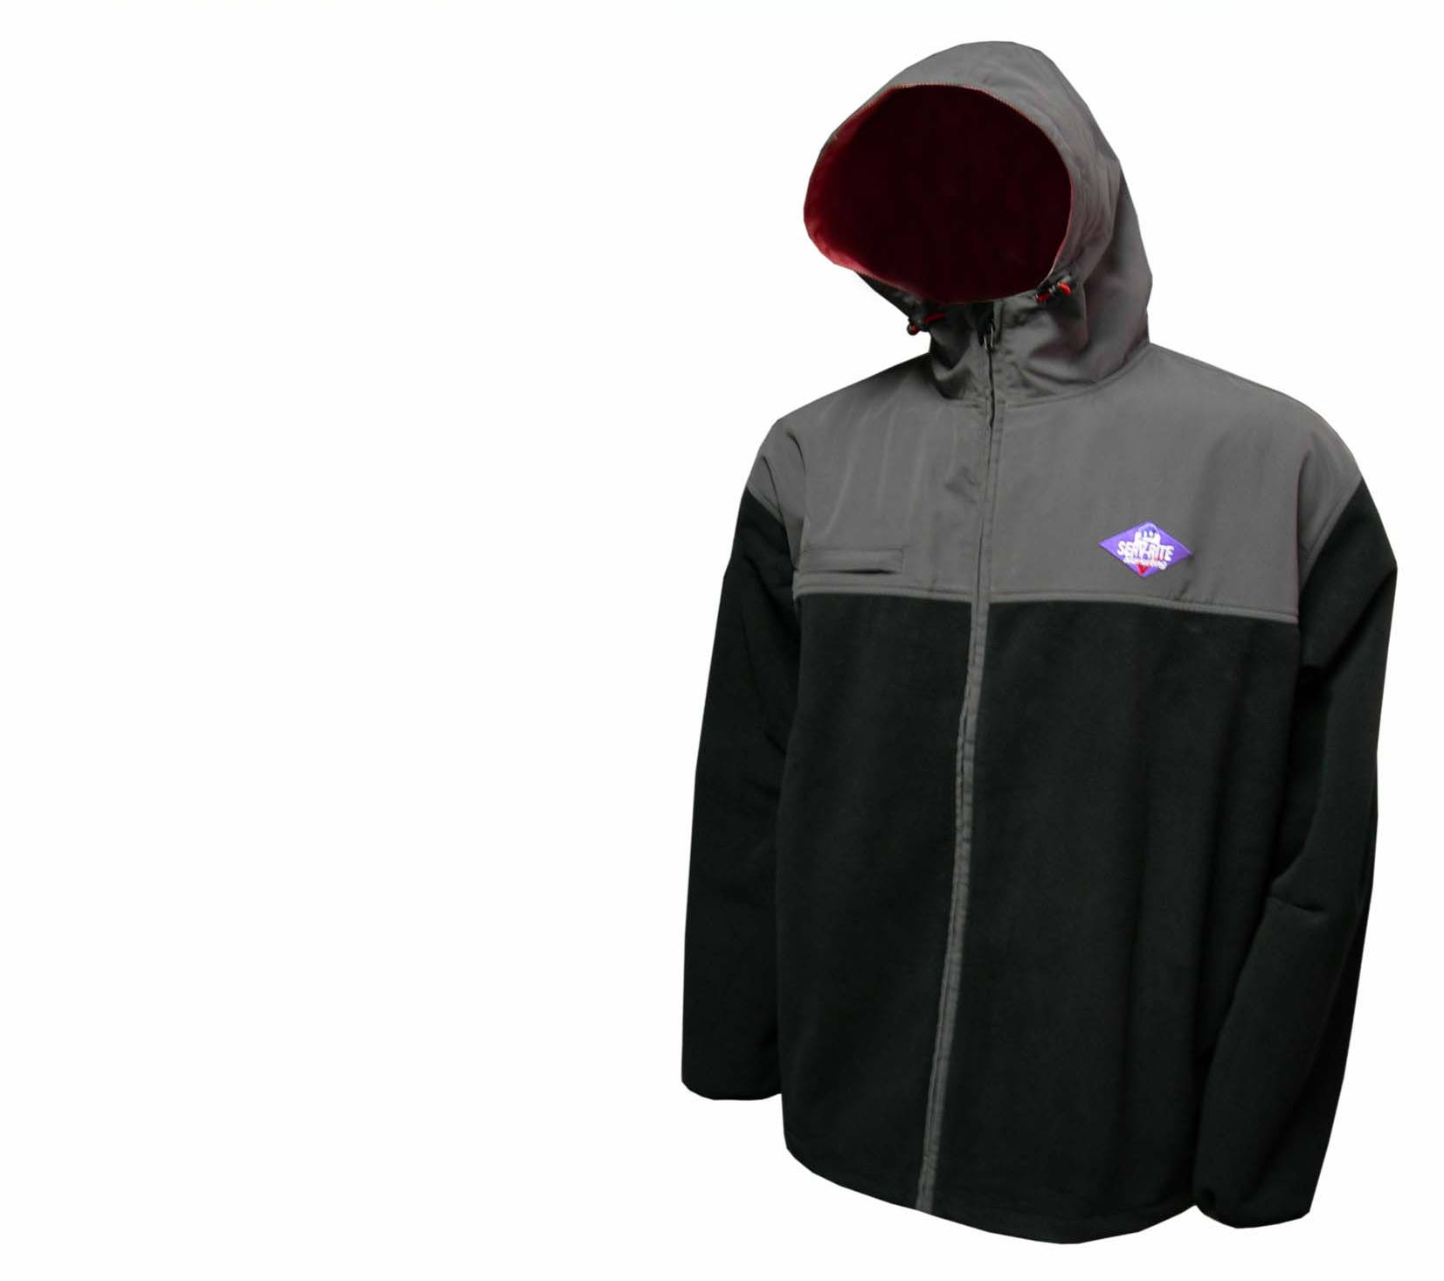

Style: Waterproof Fleece / Nylon Jacket

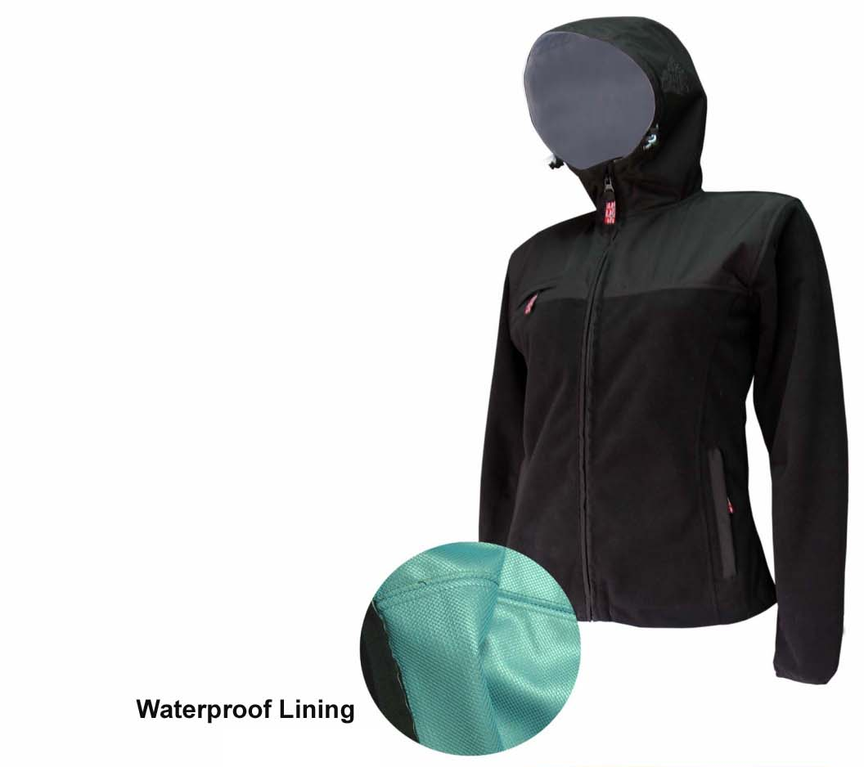

Style: Waterproof Jacket Ladies
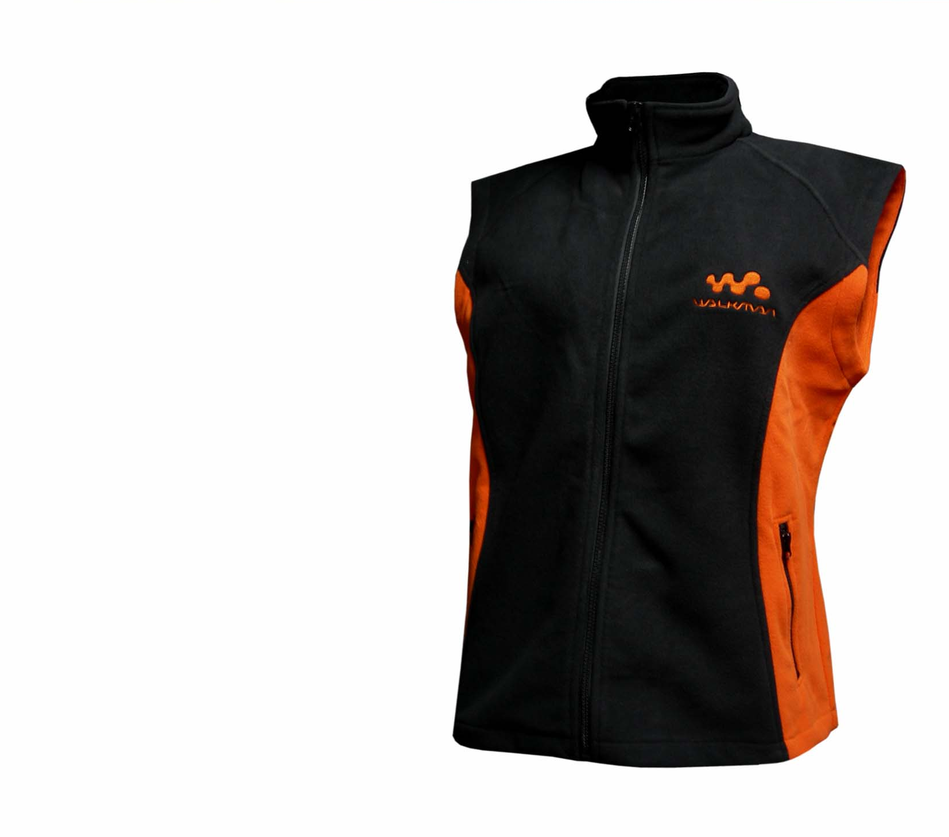

Style: Gilet 2 colors
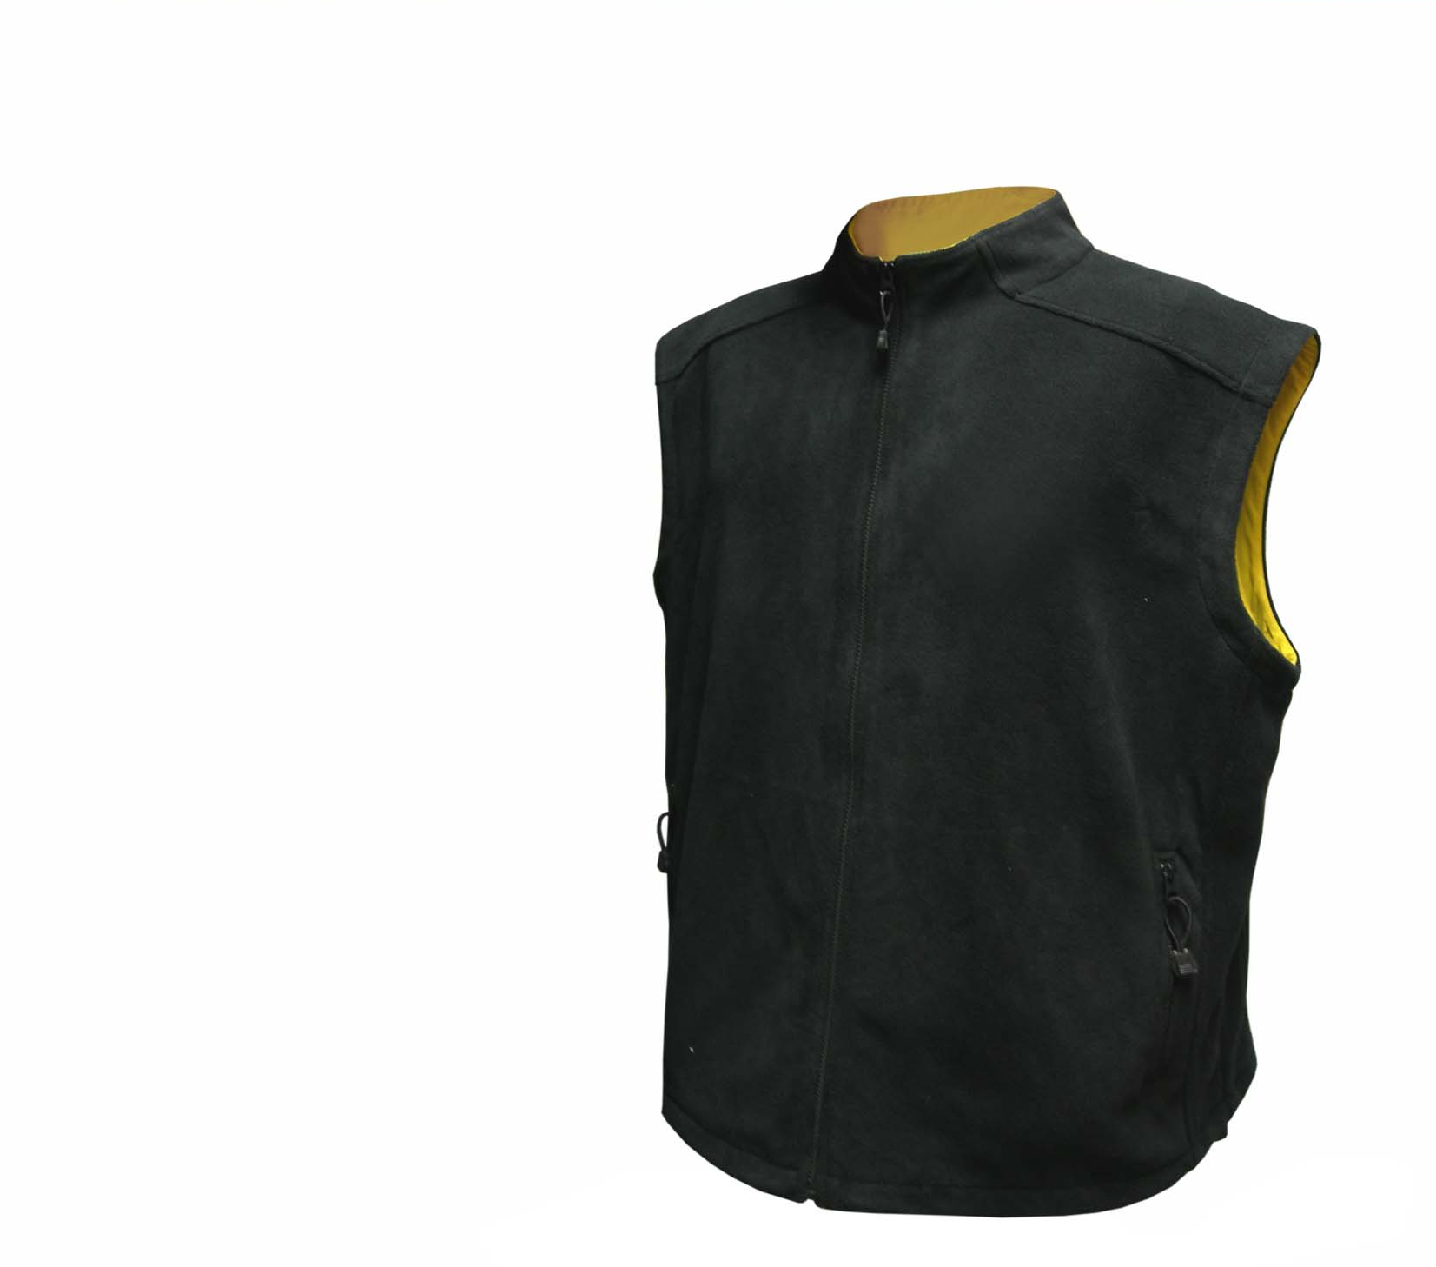

Style: Gilet with contrast color inside neck / arm

